Abdullah Safi

Amier Chery

ACST 3710

Professor Shaw

4/10/2020

Space Shmup Project Description

Primary Feature Changes:

1. Create start screen \*\*\* Abdullah Safi
2. Create game over screen \*\*\* Abdullah Safi
3. Modify enemy to shoot \*\*\* Amier Cherry
4. Optimize background scroller \*\*\* Abdullah Safi
5. Add evasive maneuver \*\*\* Amier Cherry
6. Add selectable ship models \*\*\* Amier Cherry

Secondary Feature Changes:

1. Add score text \*\*
2. Add background music \*\* Abdullah Safi
3. Add game over music \*\* Abdullah Safi
4. Add shooting sound effect \*\* Abdullah Safi
5. Make the player ship explode \*\* Abdullah Safi
6. Different color indicators for different bullet spreads\*\*
7. Add different background selections\*\*

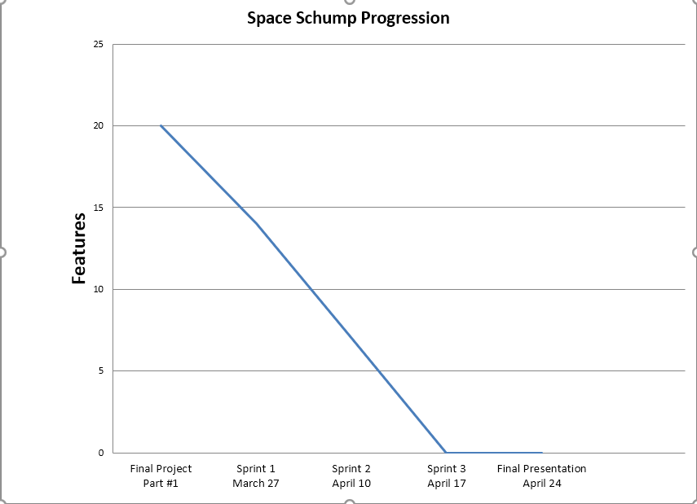

Least Important Feature Changes:

1. Press ‘R’ to restart on the game over screen \*
2. Add a quit button to the game over screen \*
3. Add a button that shows game controls\*
4. Press ‘P’ to pause the game\*
5. Add color to the player/enemies \*
6. Change stars to look more realistic \*
7. Change space background to include distant planets \*

Feature Change Details:

1. A start screen with text and the option to start the game by pressing the space key.
2. A game over screen when the player is destroyed that has several options.
3. One of the enemies can shoot laser bullets.
4. Background is now optimized so it is no longer “lagging”.
5. Player will be able to press a button and activate a maneuver that quickly jolts them out the way
6. Player will be able to select from 3 different ship models before the game starts
7. Score is displayed on the top right corner and is incremented whenever an enemy is destroyed.
8. The game has background music playing until the game over screen.
9. The game has ‘game over’ music which is played after the player is destroyed.
10. Bullets being shot by the player and enemies cause a shooting sound effect.
11. The player ship explodes after getting hit directly.
12. Bullet spreads will have more defined color differences to visually indicate when a new type of bullet is loaded
13. Player can select various backgrounds (space with milky way galaxy , blank space, supernova)
14. Press ‘R’ to restart on the game over screen which pops up on the top right corner.
15. A quit button displayed on the game over screen which pops up on the bottom middle of the screen.
16. Player will be able to press a keyboard button and a text box describing the different in-game controls will show
17. Players will be able to pause the game by pressing a button on their keyboard, and press it again to resume playing the game
18. Color to improve the appearance of the player/enemies.
19. The stars that make the space background can be more detailed, which would make for a more realistic looking game
20. The default background for the space will contain planets in the distance